# First Steps in Programming

Classroom and homework exercises for the course ["Programming-Fundamentals-and-Unit-Testing" @ СофтУни](https://softuni.bg/trainings/4256/programming-fundamentals-and-unit-testing-september-2023).

Test your solutions in the **judge system**: <https://judge.softuni.org/Contests/4290/First-Steps-In-Programming-Lab>

## Console Program "Hello, SoftUni!"

Write a **C# console program** that **prints** the text "**Hello, SoftUni!**".

### Instructions

1. Launch **Visual Studio**
2. **Create a new project**

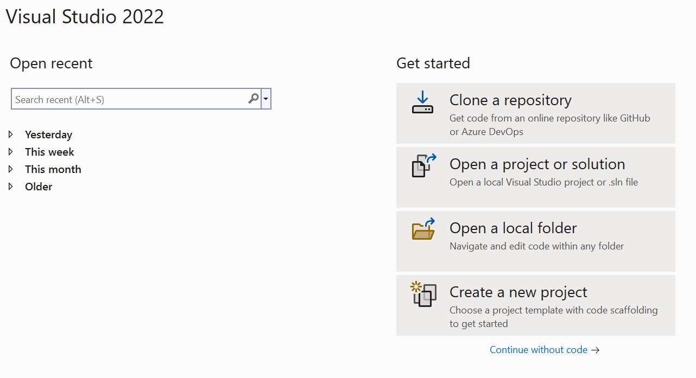

1. Select: **Console App (.NET Core)** 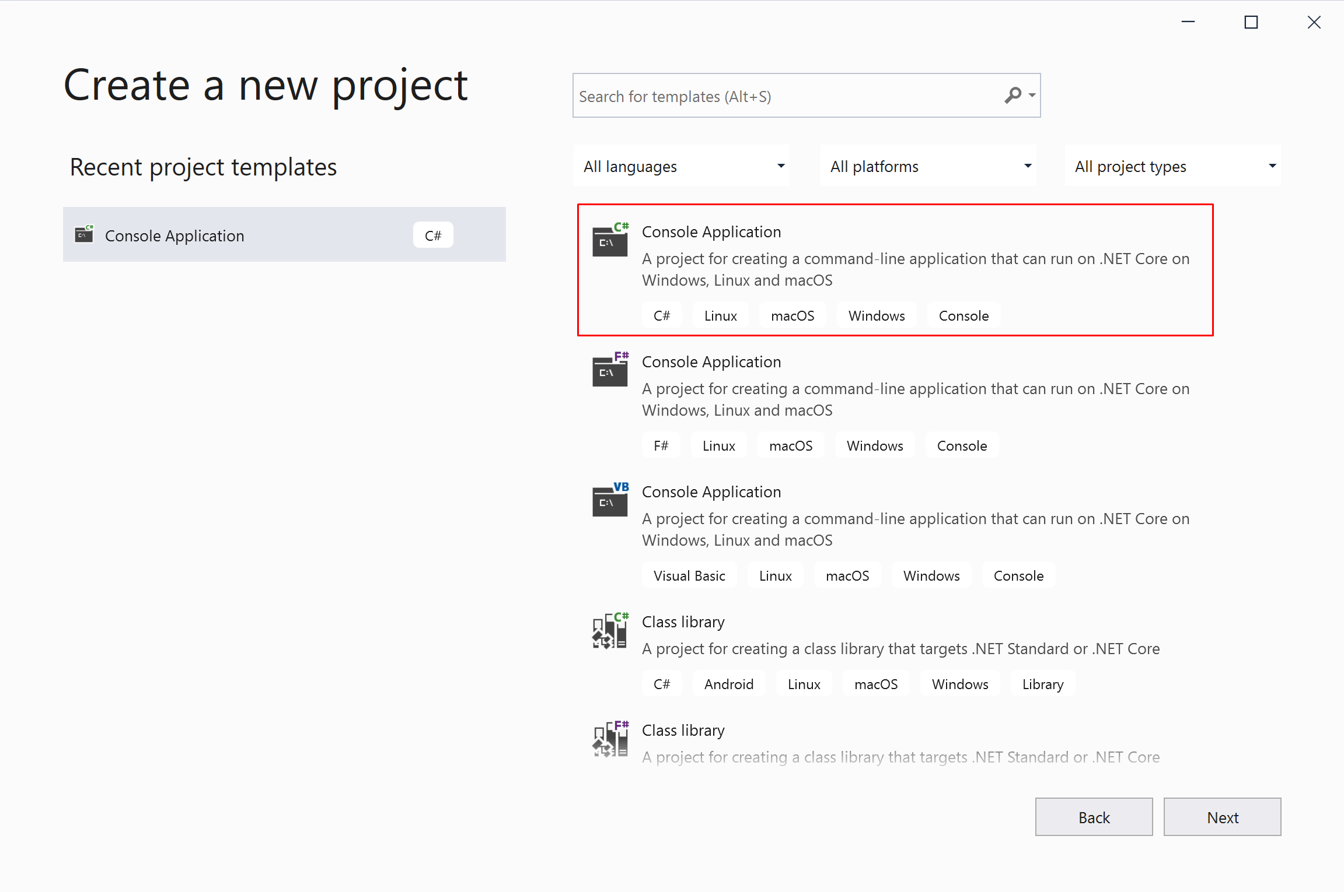
2. Enter a suitable **project name** and **directory** for the project to be created.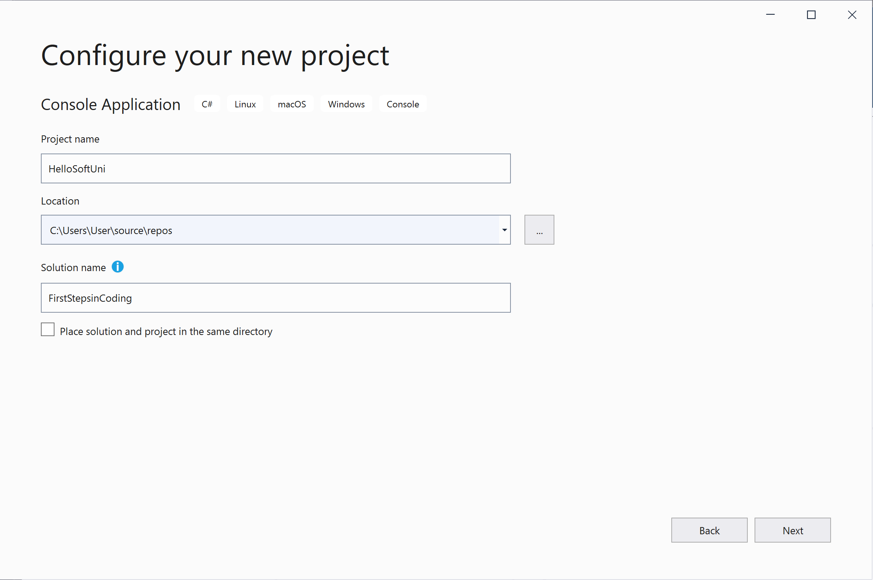 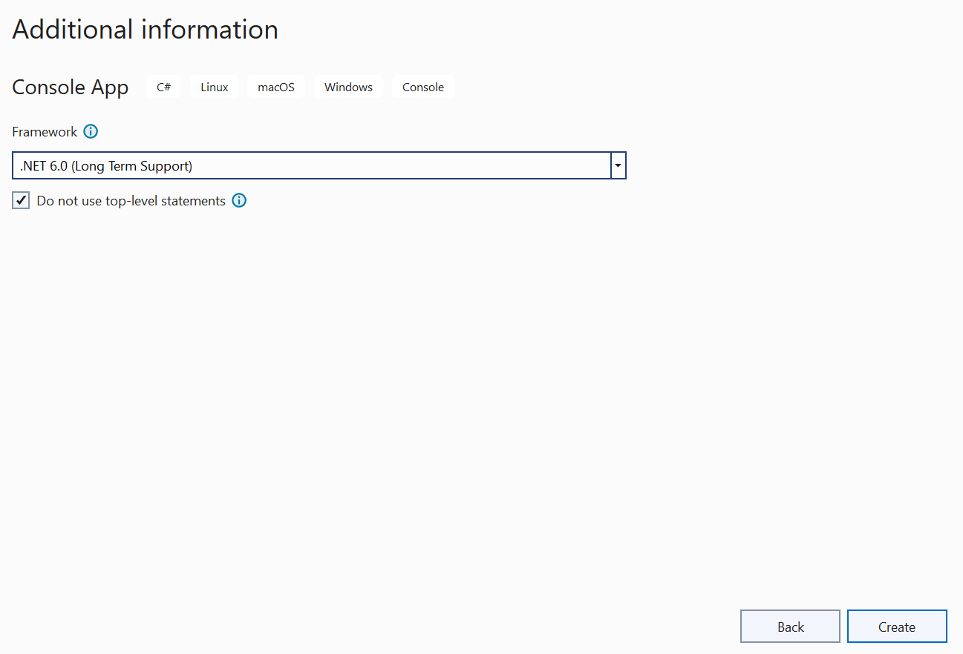
3. Find the Main(string[] args) and write C# programming code in it.
4. Position the cursor between the opening and closing curly braces { }.
5. Press **Enter** after the opening brace **{**

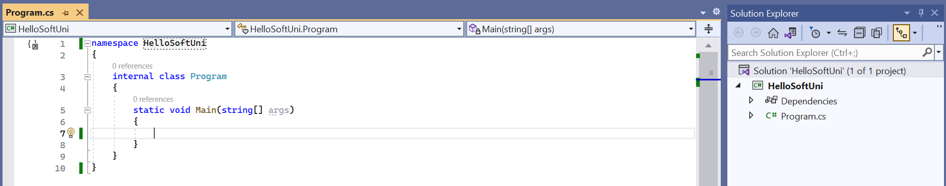

1. Write the following programming code (Command for printing text **"Hello SoftUni"**):

|  |
| --- |
| Console.WriteLine("Hello, SoftUni!"); |

Each block of code in the program is indented one tab inward from the opening curly brace {.

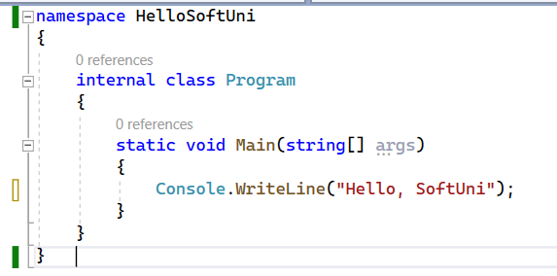

1. **Start** the program by pressing **Ctrl+F5**. You must see the following result on the **console**:

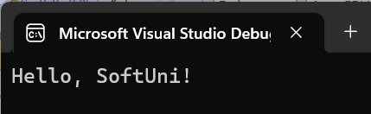

1. **Test your solution** for this task in the online **Judge system** of SoftUni. To do this first open <https://judge.softuni.org/Contests/Practice/Index/4290#0>. **Log in** with your **SoftUni username**. A window for submitting solutions for the "Hello SoftUni" task will appear. **Copy the source code from Visual Studio** and paste it into the **submission field**:

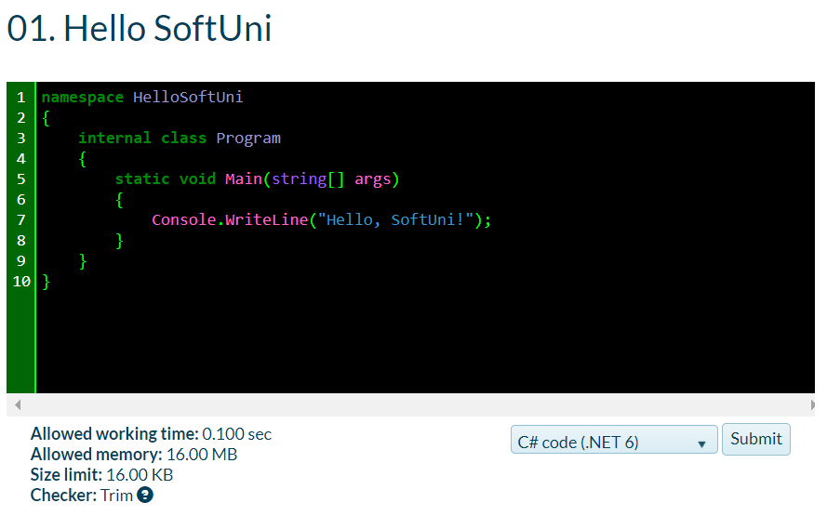

1. **Submit** your solution for evaluation using the **"Submit" button**. You will receive the **result after a few seconds** in the table of submitted solutions in the judge system:

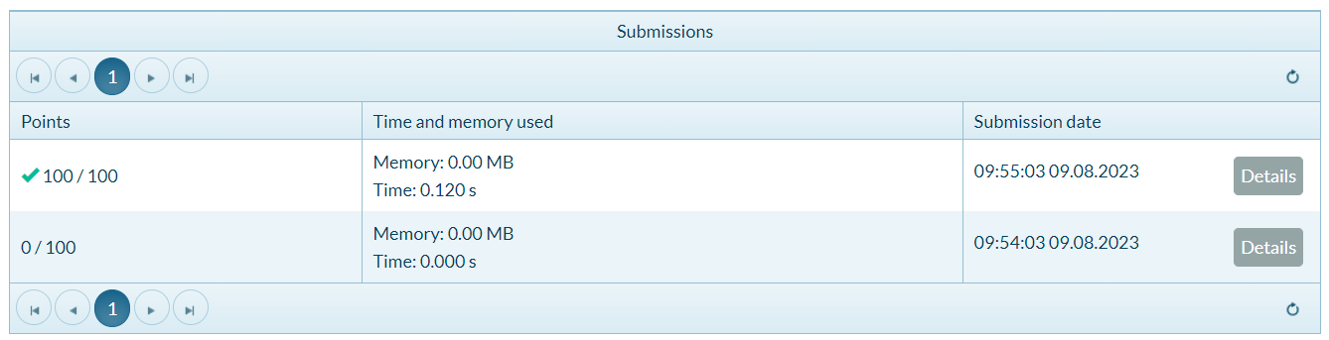

## Text Reading

Write a **console program** that **takes input** **from the console** and then **displays the entered text on the console**.

### Instructions

1. Create a console application named "TextReading".
2. **Create a string variable** and **assign** its **value** from the **console input**. You can use the following command: Console.ReadLine().

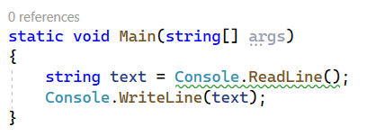

1. **Test** your solution in the [Judge](https://judge.softuni.org/Contests/Practice/Index/4290#1) system.

## Square Area

Write a **console program** that **reads the length of one side of a square** from the console, **calculates the area**, and **displays the result on the console**.

### Example Input/Output

|  |  |
| --- | --- |
| **Input** | **Output** |
| 2 | 4 |

|  |  |
| --- | --- |
| **Input** | **Output** |
| 6 | 36 |

### Instructions

1. **Initialize** an int variable (a) and **assign a value** from the **input from the console**:  
    
2. Initialize a second variable named **area,** in which you will **store the value for the square’s area**, obtained using **the formula a * a. Print the resulting value.**

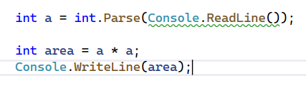

## Inches to Centimeters Converter

Write a console program that **reads a length in inches** from the console, **converts it to centimeters**, and displays the **converted length on the console**. For that purpose, **multiply the inches by 2.54** (1 inch = 2.54 centimeters).

### Example Input/Output

|  |  |
| --- | --- |
| **Input** | **Output** |
| 5 | 12.7 |

|  |  |
| --- | --- |
| **Input** | **Output** |
| 7 | 17.78 |

**Attention: Depending on the regional settings of the operating system, instead of a decimal point (US settings), a decimal comma (BG settings) may be used. If the program expects a decimal point and a number with a decimal comma is entered, or vice versa (a decimal point is entered when a decimal comma is expected), the following error will occur:**  
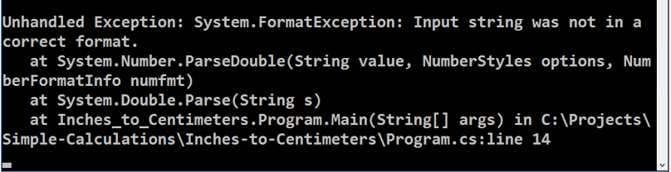**It is recommended to adjust your computer settings to use a decimal point:**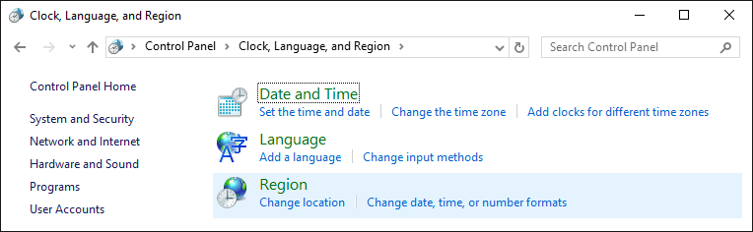

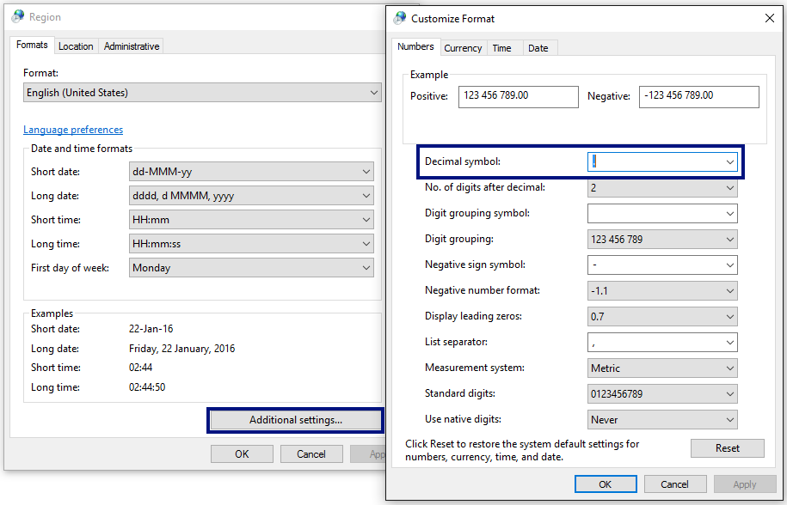

## Excellent Grade Check

Write a **console program** that **reads a grade** (floating point number) entered by the user and prints **"Excellent!"** if the grade is **equal to or greater than** **5.50**.

### Instructions

1. **Initialize** a **double** variable (**grade**) and **assign a value** from the **input from the console**:

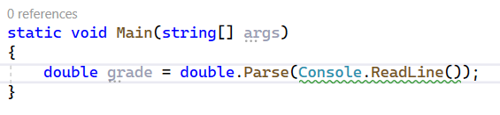

1. Check if the value meets the condition and if so, print the desired result on the console:

### Example Input/Output

|  |  |
| --- | --- |
| **Input** | **Output** |
| 6 | Excellent! |
| 5 | (no output) |
| 5.50 | Excellent! |
| 5.49 | (no output) |

## Grades If-Else

### Write a console program that reads a grade value (floating point number) as input from the console. The program should then evaluate the grade and display appropriate messages based on the following conditions:

### If the entered grade is equal to or greater than 5.50, the program should display "Excellent!"

* If the entered **grade is less than 5.50**, the program should display **"Not excellent.”**

### Instructions

1. Use the previous program and **add another validation** for the grades that are **less than 5.50**:

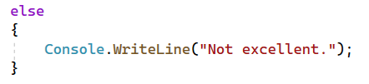

### Example Input/Output

|  |  |
| --- | --- |
| **Input** | **Output** |
| 6 | Excellent! |
| 5 | Not excellent. |
| 5.50 | Excellent! |
| 5.49 | Not excellent. |

## Even or Odd

Create a **console program** that assesses whether a given **integer is odd or even**. The program should follow these steps:

1. **Read an Integer Input**: The program should read a value from the console using the **Console.ReadLine()** method. **Convert the input** to an integer **using int.Parse()** and store it in the variable **num**.



1. **Evaluate if the Integer is Even or Odd**: Use a conditional statement (**if-else**) to check if the value of num is **evenly divisible by 2**. To do this, calculate **num % 2** (the remainder when dividing num by 2). If the remainder is **0**, it means **num is even**; if the remainder is **1**, it means **num is odd**.

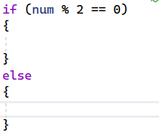

1. **Display the Result**: **If num is even** (the remainder is 0), use **Console.WriteLine() to print "even"** on the console.

**If** **num is odd** (the remainder is 1), use **Console.WriteLine() to print "odd"** on the console.

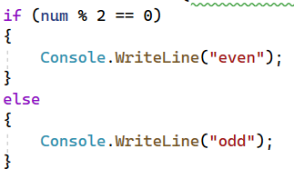

### Example Input/Output

|  |  |
| --- | --- |
| **Input** | **Output** |
| 2 | even |
| 5 | odd |
| 13 | odd |
| 100 | even |

## The Greater Number

Create a **console program** that **compares two integer values** and **determines the greater number**. Follow these steps to create the program:

1. **Read Two Integer Inputs**: The program should **read two integer values from the console** and **store them** in **variables num1** and **num2** respectively.



1. **Compare the Numbers**: Utilize a series of **conditional statements** (if, else if, and else) to compare the values of num1 and num2. Check the following conditions:

* If **num1 is greater than num2**, display **"Greater number: [num1]"** on the console.
* If **num1 is less than num2**, display **"Greater number: [num2]"** on the console.
* If **num1 is equal to num2**, display **"The two numbers are equal."** on the console.

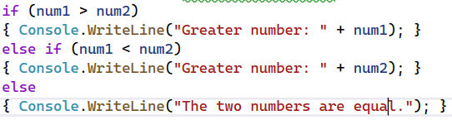

### Example Input/Output

|  |  |
| --- | --- |
| **Input** | **Output** |
| 6  3 | Greater number: 6 |
| 2  5 | Greater number: 5 |
| 10  10 | The two numbers are equal. |

## Numbers' Names

Create a **console program** that **converts a numeric input** into its corresponding **word representation**. Here's how you can construct the program:

1. **Read an Integer Input**: The program should **read an integer value** from the console and **store it in a variable**.
2. **Convert to Word**: Use a series of **conditional statements** (if, else if) to match the value of num with its corresponding word representation.
3. Check the following conditions:
   * **If** num is **1**, display **"one"** on the console.
   * **If** num is **2**, display **"two"** on the console.
   * **If** num is **3**, display **"three"** on the console.
   * **If** num is **4**, display **"four"** on the console.
   * **If** num is **5**, display **"five"** on the console.
   * **If** num is **6**, display **"six"** on the console.
   * **If** num is **7**, display **"seven"** on the console.
   * **If** num is **8**, display **"eight"** on the console.
   * **If** num is **9**, display **"nine"** on the console.
   * **If** num is **10**, display **"ten"** on the console.
   * **If** num is **none** of the above, display **"number out of range"** on the console.

### Example Input/Output

|  |  |
| --- | --- |
| **Input** | **Output** |
| 2 | two |
| 5 | five |
| 10 | ten |
| 100 | number out of range |

## Days of the Week

Create a **console program** that identifies the **name of a day based on a numeric input**. Here's how you can construct the program:

1. **Read an Integer Input**: The program should **read an integer value** from the console and **store it in the variable "day"**.
2. **Convert to Word**: Use a **switch statement** to **match the value of the day** with the corresponding **week’s day name**.
3. Check the following conditions:
   * **If** day is **1**, display **"Monday"** on the console.
   * **If** day is **2**, display **"Tuesday"** on the console.
   * **If** day is **3**, display **"Wednesday"** on the console.
   * **If** day is **4**, display **"Thursday"** on the console.
   * **If** day is **5**, display **"Friday"** on the console.
   * **If** day is **6**, display **"Saturday"** on the console.
   * **If** day is **7**, display **"Sunday"** on the console.
   * If day is **any other number,** display "Error" on the console.

### Example Input/Output

|  |  |
| --- | --- |
| **Input** | **Output** |
| 1 | Monday |
| 2 | Tuesday |
| 3 | Wednesday |
| 4 | Thursday |
| 5 | Friday |
| 6 | Saturday |
| 7 | Sunday |
| 8 | Error |

## Animal Types

Create a **console program** that **classifies** **animals based on their types**. Here's how you can construct the program:

1. **Read Animal Input**: The program should **read a text value** from the console and **store it in the variable "animal"**.
2. **Classify The Animal**: Use a **switch statement** to **match the input value** with thecorresponding **animal type**.
3. Check the following conditions:

* If the **animal is "dog"**, display **"mammal"** on the console.
* If the **animal is "crocodile"**, **"tortoise"**, or **"snake"**, display **"reptile"** on the console.
* If **none of the above cases** match, display **"unknown"** on the console.

### Example Input/Output

|  |  |
| --- | --- |
| **Input** | **Output** |
| dog | mammal |
| crocodile | reptile |
| tortoise | reptile |
| snake | reptile |
| frog | unknown |